**The following is simplistic outline of the minimum required to create a new debtor in Tramada and Serko.**

Screenshots and tick boxes are to give an idea and would need to be reviewed and confirmed before progressing on project.

**Tramada Build basics:**

Create Debtor

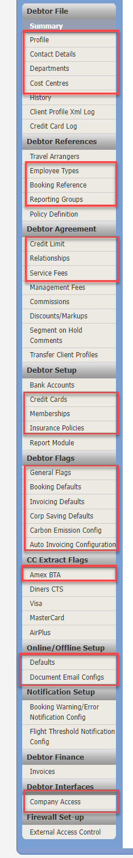Configure Debtor:

File

* Profile
  + Rate Codes, OSI’s, GDS Upload Freetext, GDS (possibly not to be included in RPA)
  + Administration
* Contact Details
  + Debtor Contact, Other Contact, Accounts Contact
* Departments
* Cost Centres

References

* Employee Type
* Booking References (possibly not to be included in RPA)
* Reporting Groups

Agreement (possibly not to be included in RPA)

* Credit Limit
* Relationships
* Service Fees

Setup

* Credit Cards (not to be included in RPA)
* Memberships
* Insurance Policies

Flags

* General Flags
* Booking Defaults
* Invoicing Defaults
* Corp Savings Defaults
* Auto Invoicing Configuration

CC Extract Flags

* Amex BTA if required (not to be included in RPA)

Online/Offline Setup

* Defaults
* Document Email Configs

Interfaces

* Company Access

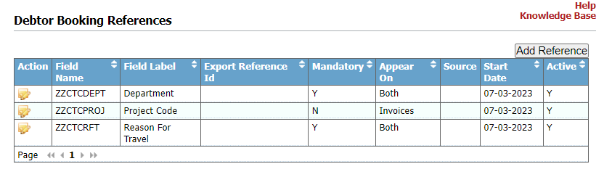

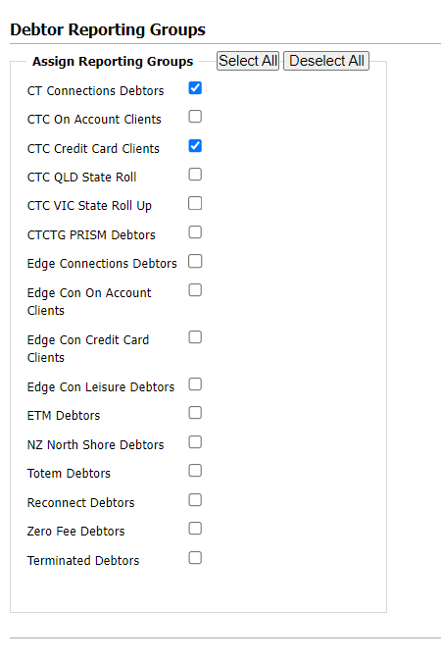

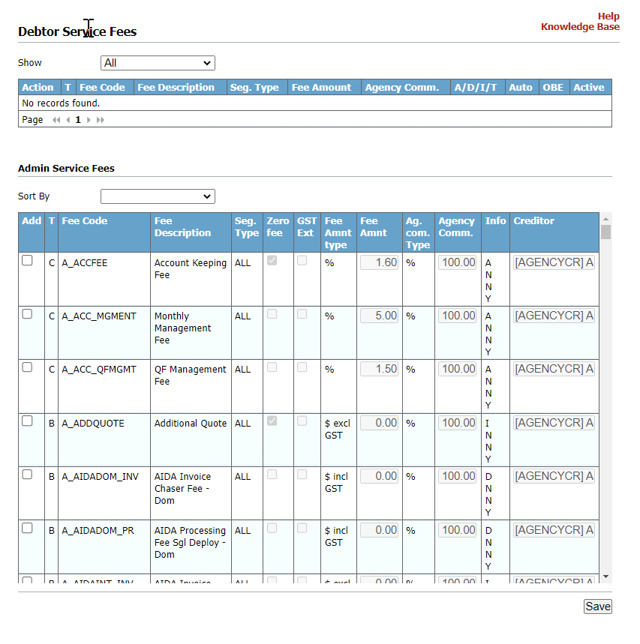

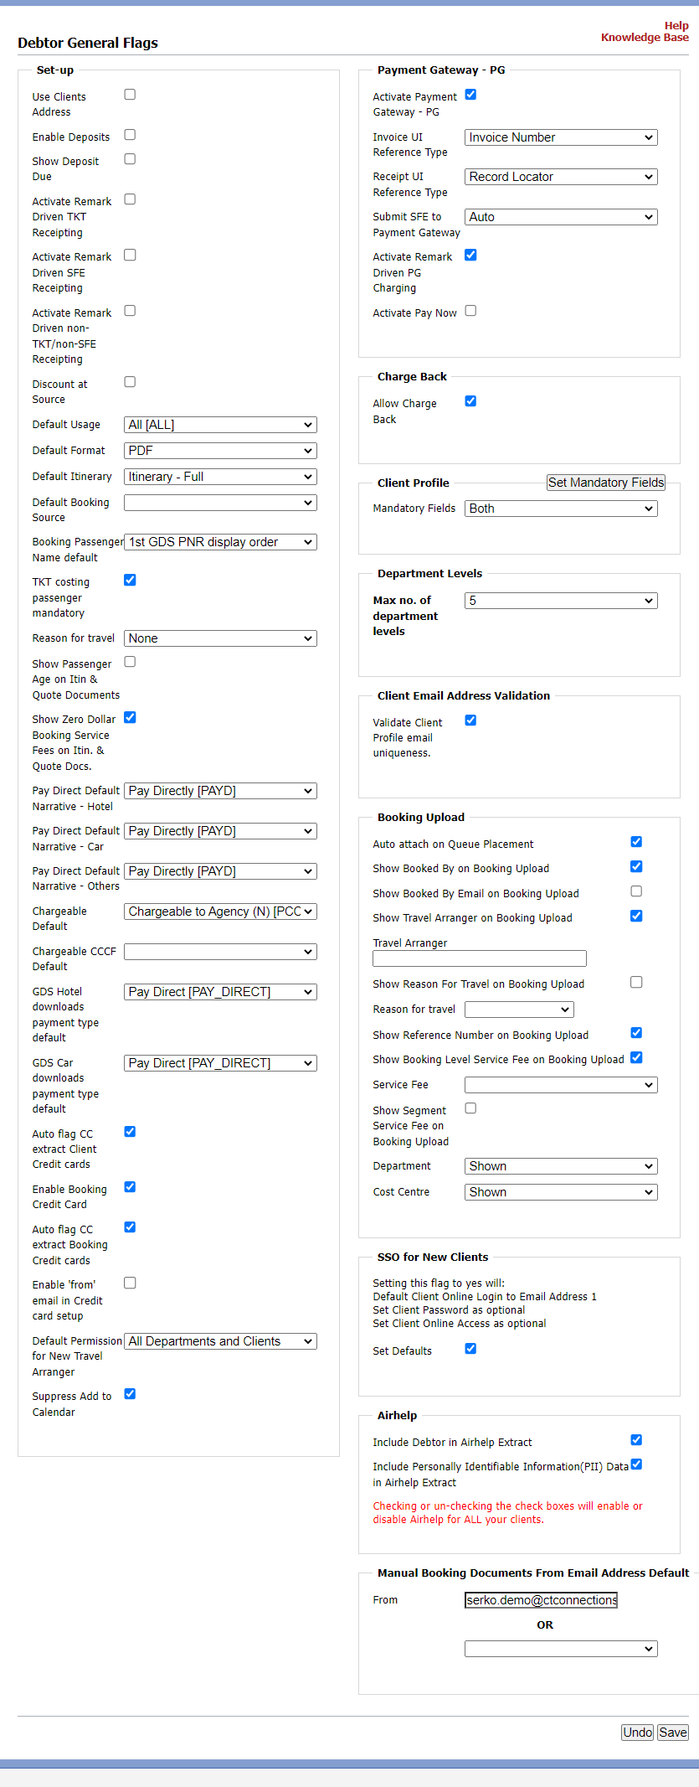

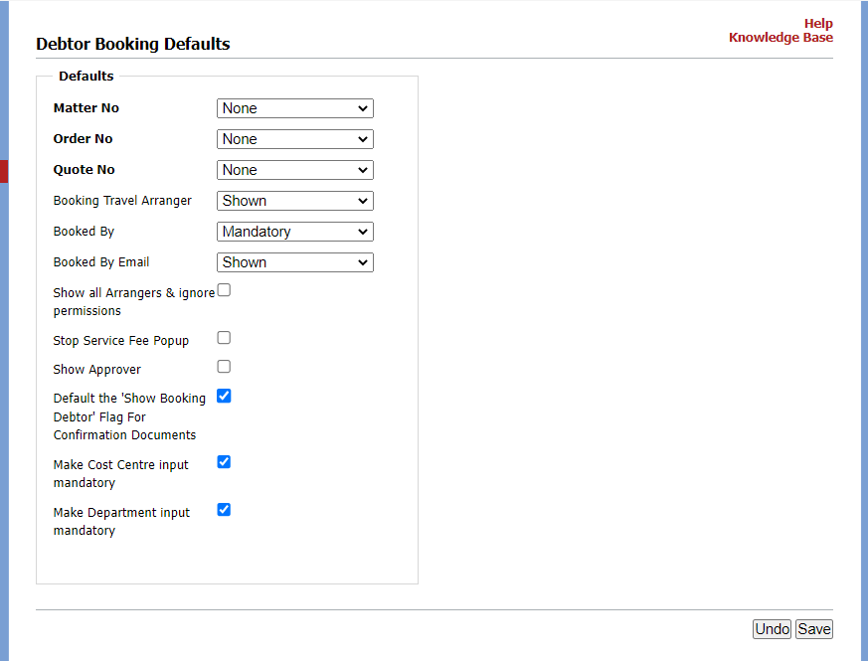

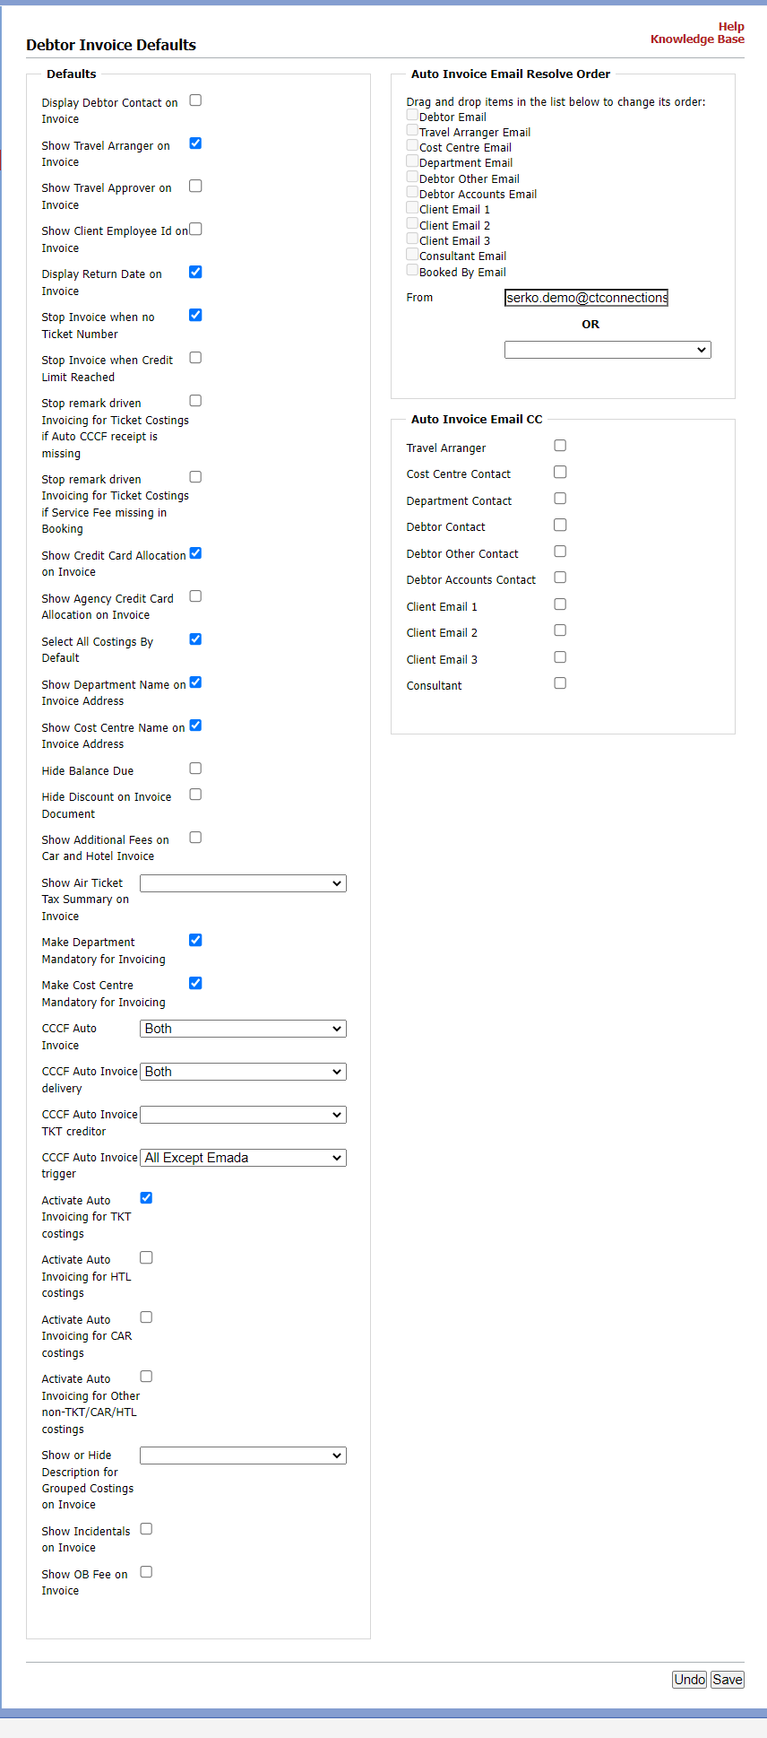

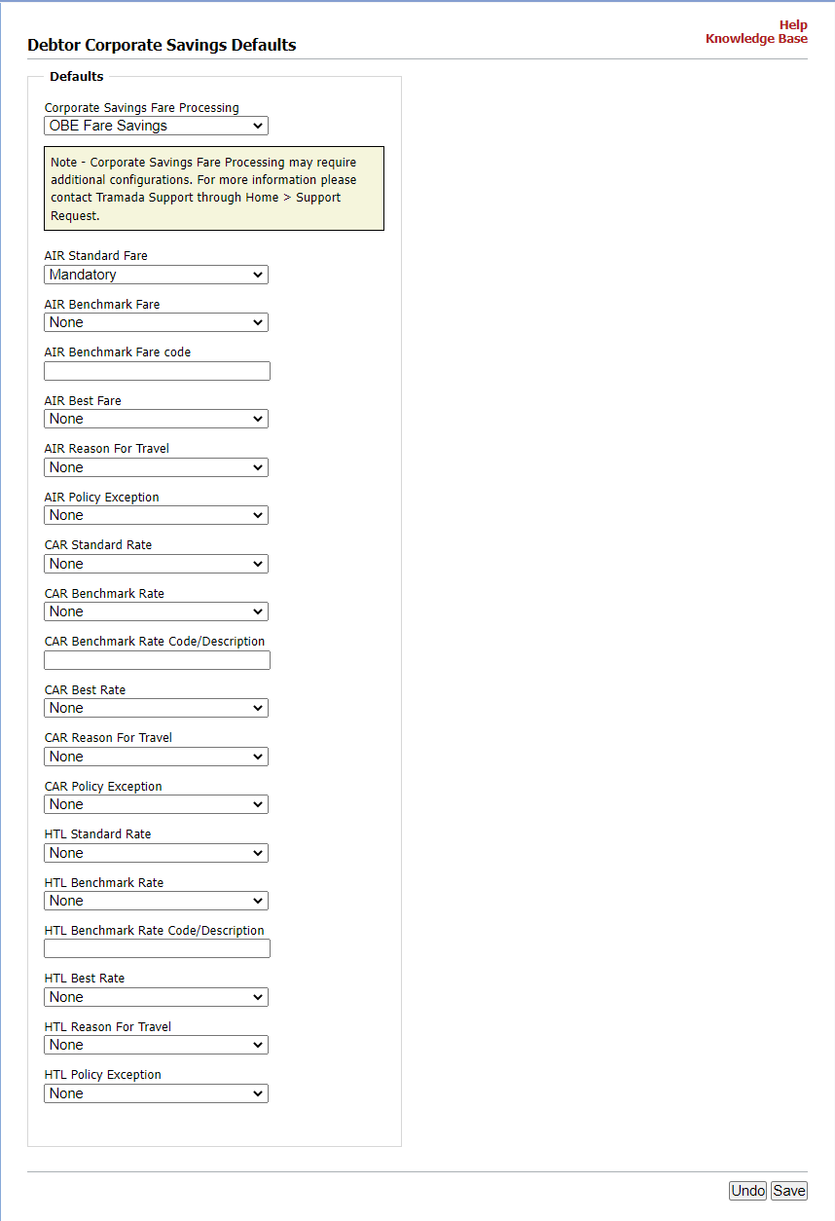

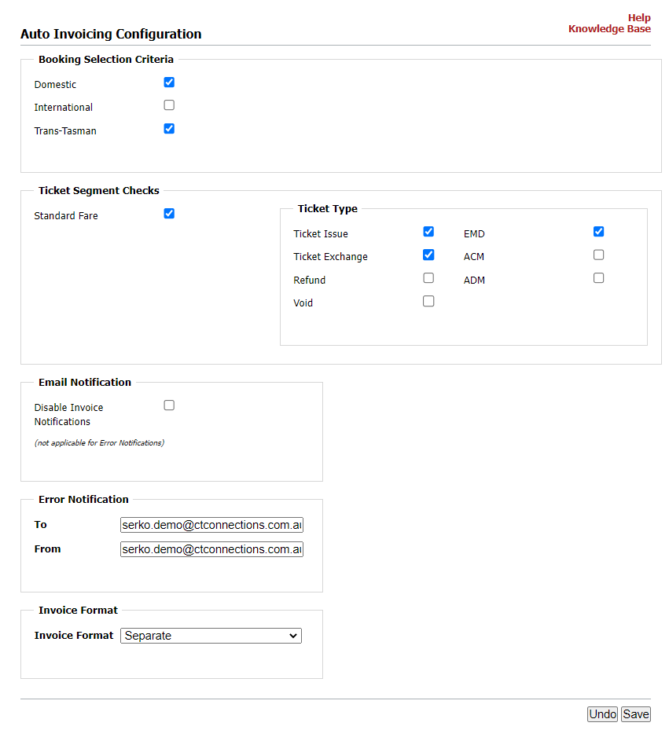

**Serko Build Basics**

**Areas required to be accessed for a new build:**

**STEPS**

1. Clone Master Corporate Profile to create new Master Corporate for Debtor

* Find and Open Master Corporate
* Clone

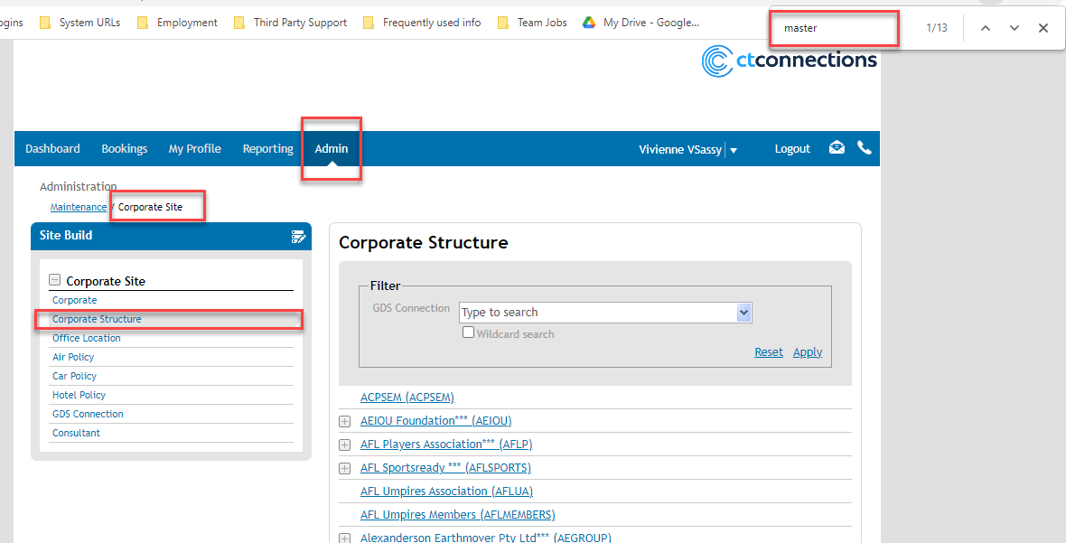

1. Clone and Create Role Groups

|  |
| --- |
|  |
|  |
|  |

1. Create Arranger and Auth profiles

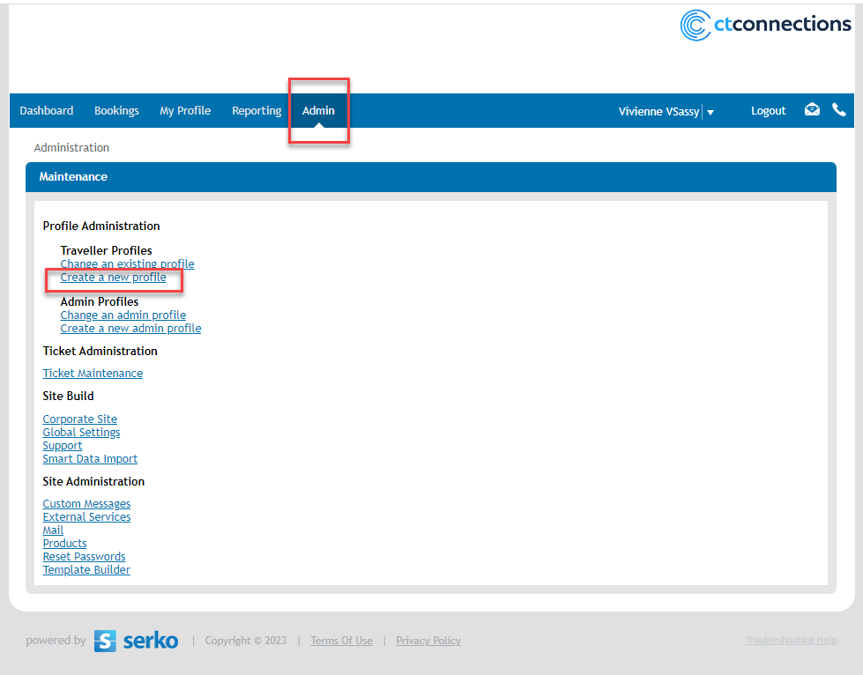

1. Dom/TT/Int Car Policy created and linked to master corp

1. Dom/TT/Int Hotel Policy created and linked to master corp

1. Dom/TT/Int Air Policy created and linked to master corp

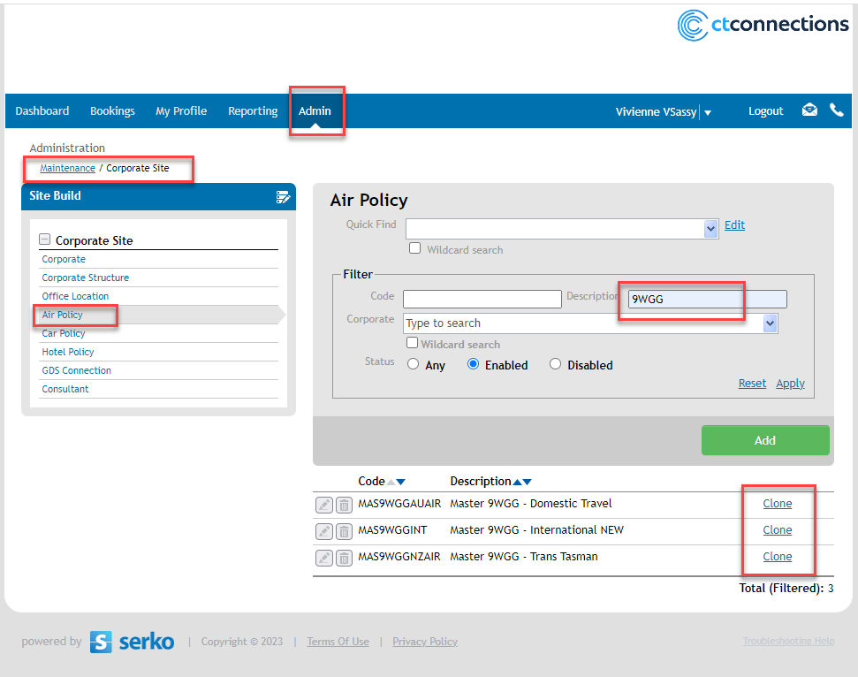

1. Air policies linked to Car and Hotel Policies

1. Create PNR Template and configure

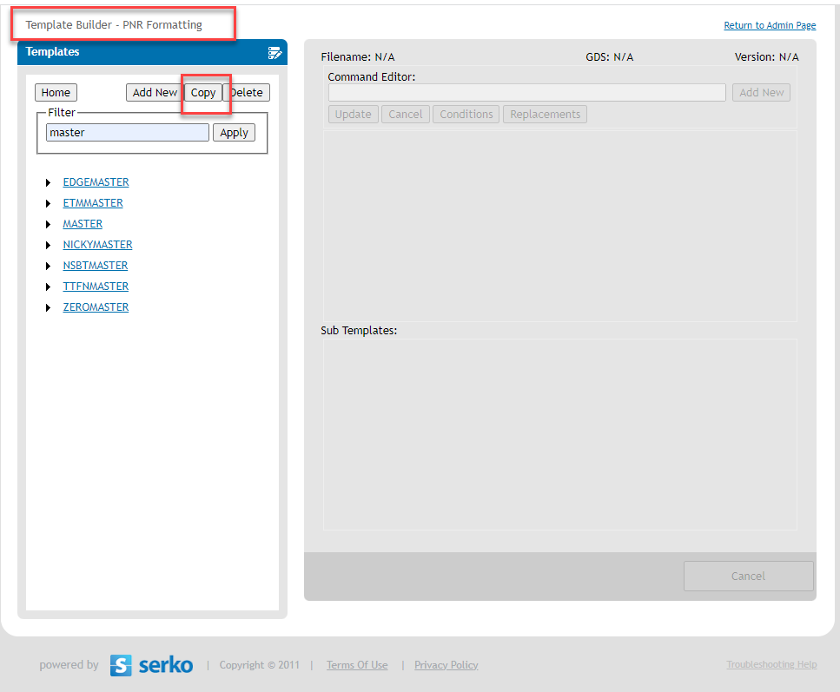

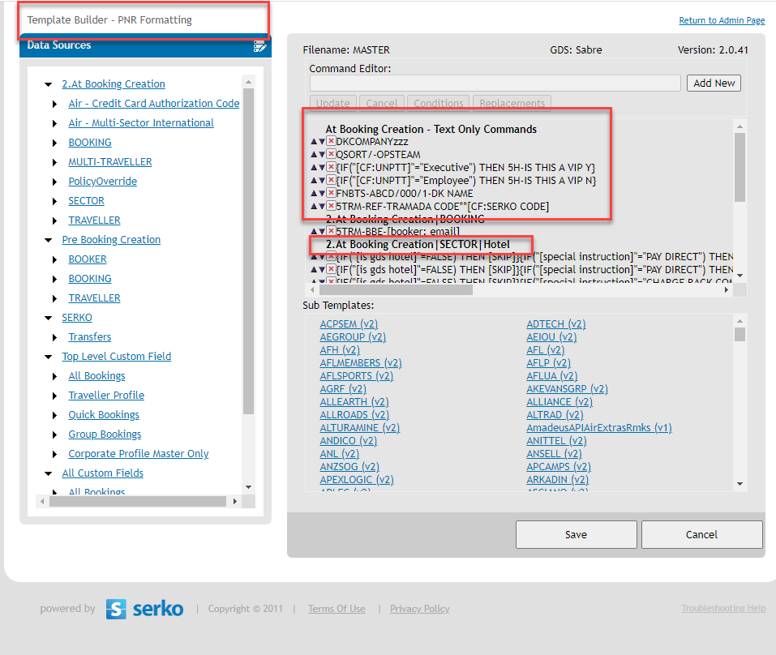

1. Configure Master corp with correct emails, queues etc. Have marked all areas we configure in large screen shot at bottom of doc.
2. Upload Cost Centres – Either by cloning or an upload. (not to be included in RPA)
3. Upload Profiles – By an upload. (not to be included in RPA)

